
Autumn 1 in pre-school 2026



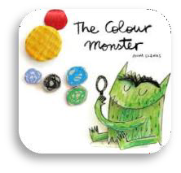
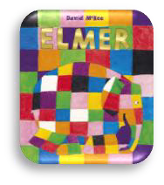
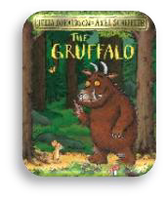
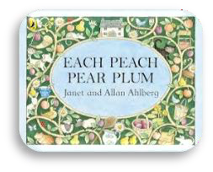
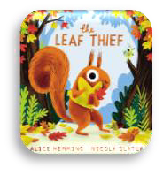
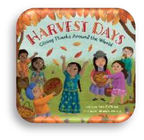
Welcome to the Autumn 1 term in pre-school! We are looking forward to a busy and exciting half term as the children settle in, make new friends and begin exploring our stories and learning themes together. This half term our topic is called Let’s Explore as we will be exploring pre-school and the world around us.

Staff
Our pre-school team are excited to support your child’s learning and development this term. We work closely together to ensure the children feel safe, happy and confident as they begin their pre-school journey.

Pictures of pre-school staff Mrs Hodnett, Mrs Webb, Mrs Garnett & Mrs Scully. (from L-R)

Reminders and Expectations
Please ensure your child comes to pre-school with a named water bottle and a coat suitable for the changing autumn weather. We encourage independence, kindness and good listening, and we will continue to support the children in following simple routines and expectations each day.

How You Can Support Your Child at Home
Encouraging independence with dressing, toileting and tidying up will also support them in becoming more confident and independent learners.
Reading regularly to your child and talking about the stories we share in pre-school will help to build their confidence and language skills.
We will be using the texts below to enhance their learning.

Communication and Language
Children will listen to and talk about the stories and develop their attention and understanding. They will learn new vocabulary linked to emotions, colours, characters and harvest, and will begin to express their ideas and feelings in conversations and role play.

Personal Social and Emotional Development
Children will explore feelings, individuality and celebrating differences, building confidence in talking about their own emotions. Harvest activities will encourage sharing, turn-taking and understanding the importance of kindness and helping others.

Physical Development
Children will develop their fine motor skills through colouring, painting, cutting and collage
activities. Outdoor play and movement activities will help to build coordination, balance and spatial awareness.

Literacy
Children will join in with repeated phrases from stories supporting early storytelling skills. They will explore mark-making through drawing characters, colouring monsters and creating their own simple pictures and symbols.

Maths
Children will explore colours, matching and sorting through activities. They will also begin to learn counting, comparing size, and exploring patterns will support early number awareness and mathematical language.

Understanding the World
Through stories and discussions, they will begin to understand similarities and differences between themselves and others, celebrating uniqueness and community. Children will begin to learn about seasonal change and start to notice differences.

Expressive Arts and Design
Children will experiment with colour mixing, printing and collage. They will use role play and small world resources to retell familiar stories and create their own imaginative ideas.

